Sheet 1
Scientists believe that all matter is made of tiny particles and from this they have developed the Particle Theory of Matter
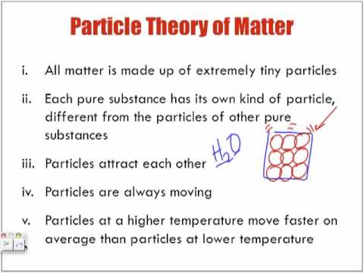
Matter normally exists in 3 states: solid, liquid or gas.
In solids particles vibrate in fixed positions. Vibrate means to move backwards and forwards or up and down quickly and repeatedly. The particle in a solid stay in a fixed space and do not permanently move away from the particles that they are bonded to.
In liquids particles move by rolling over one another.
In gasses particle move rapidly and randomly.

Why do you think liquids can flow?

Which other state of matter is able to flow?

What happens to the speed of particles in matter if they are heated?

